Information about

Medication

Antidepressant Medication
my medication
is called

medication
....................................
....................................
....................................
....................................

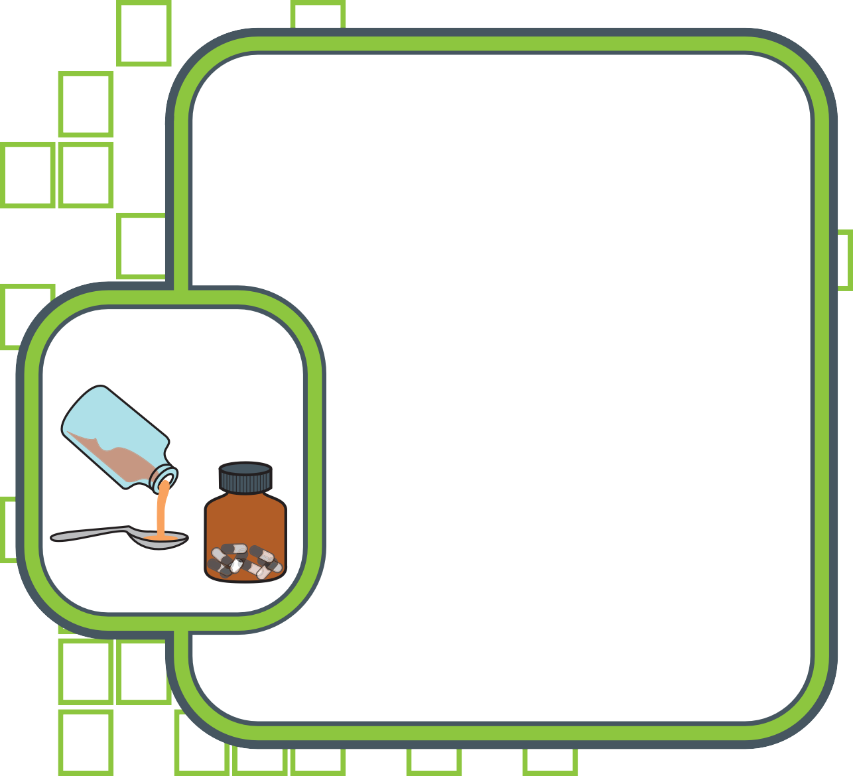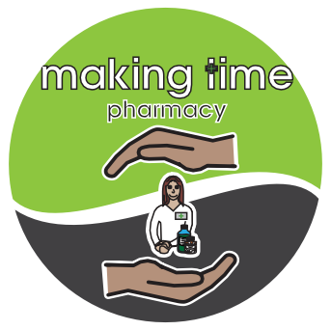

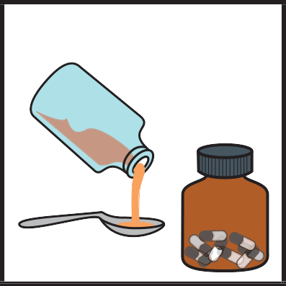
Why have I been given this medication?
medicine
This medication is to help people who are:
- Feeling unhappy or depressed
- Feeling anxious or having panic attacks
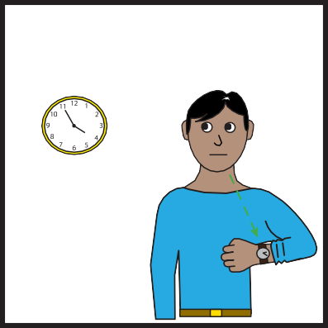
When do I take my medication?
what time
Your doctor will tell you when to take your medication.
Your doctor will tell you how much medication you need to take.


When will I feel better?

It usually takes 2 to 6 weeks for the medication to work.

If you do not feel better after 6 weeks you should see your doctor.
feeling better

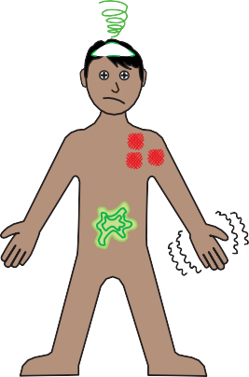
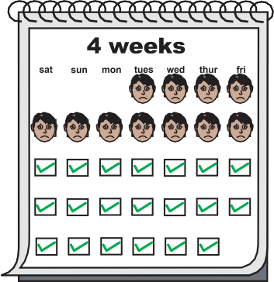

Will there be side effects?

Some people will have side effects
from their medication.

Your doctor will tell you about how your medication might make you feel.

Side effects from medication usually
stop after a few weeks.

?
Who do I speak to if I have problems?
If you have any problems with your medication you should tell your
- Pharmacist. • Carer.
- Doctor.
- Nurse.
speak

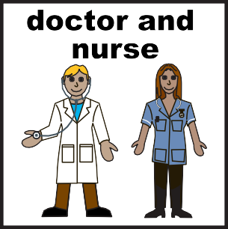
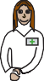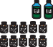
If you want more information about your medication ask your pharmacist

or you could ask your
doctor or nurse

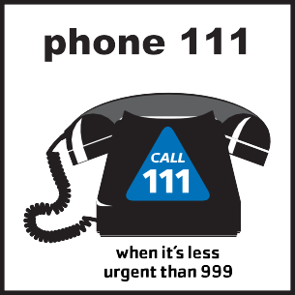
You can get information and advice about your health by calling 111

Or visiting the NHS Choices website at
www.nhs.uk

With special thanks to Leeds and York Partnership NHS Foundation Trust, Leeds North CCG, Leeds City Council, Community Pharmacy West Yorkshire and Easy On The i.

