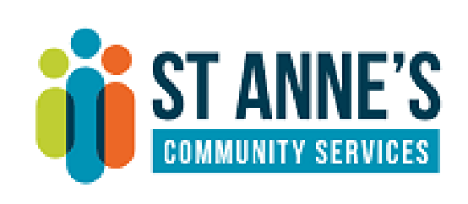
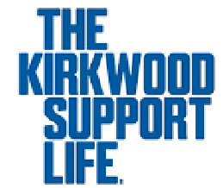
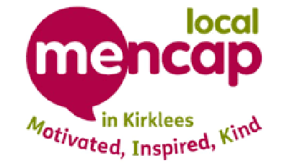
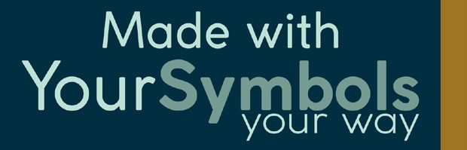
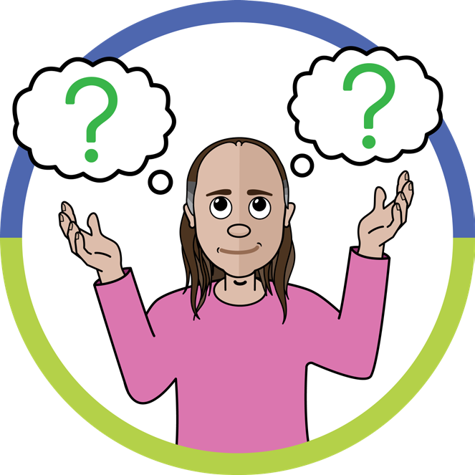
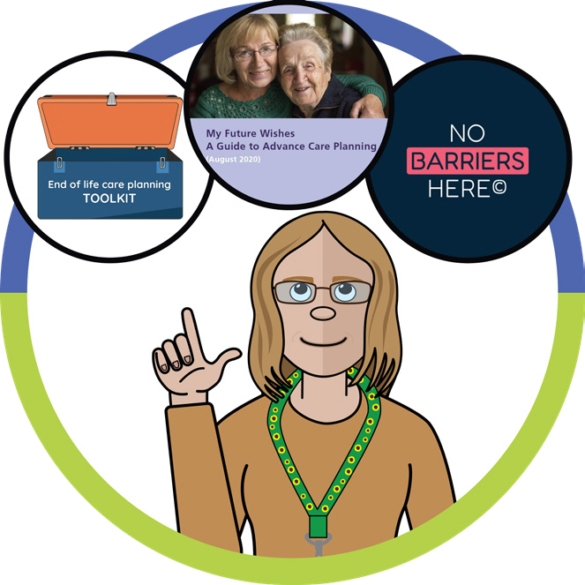
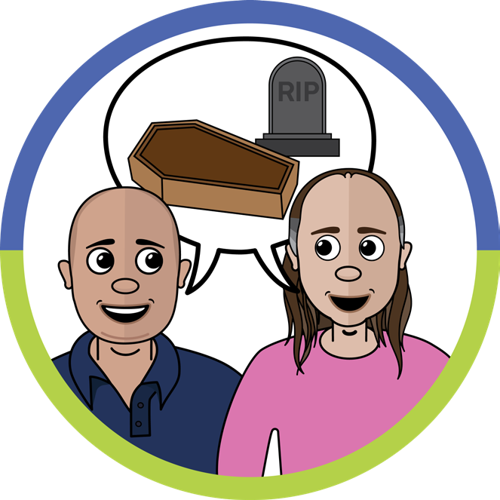
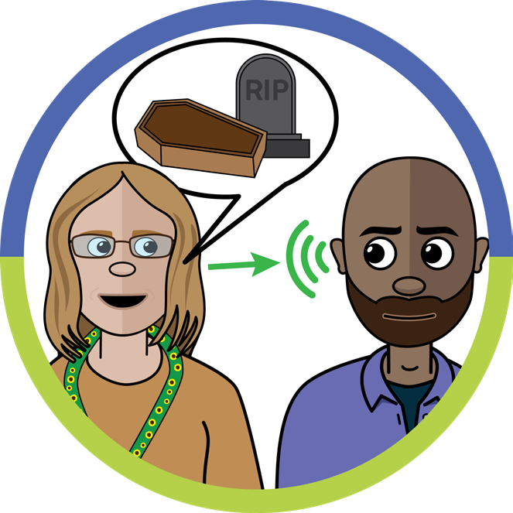
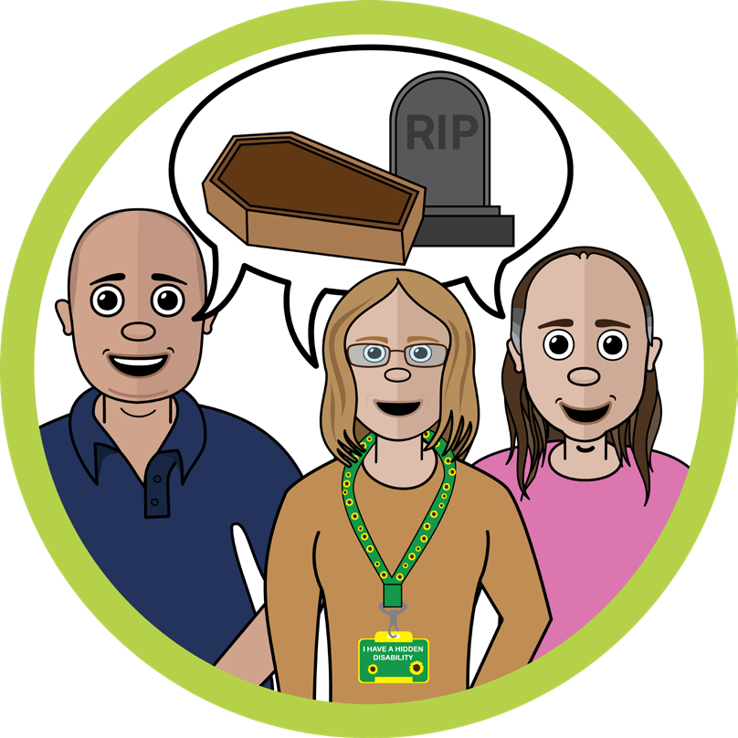
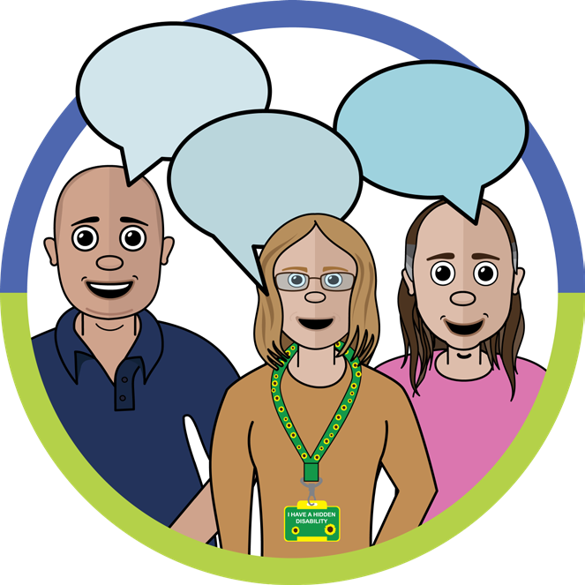
Talking About Dying
Death and dying doesn’t
have to be scar
y
Why?

Because people with learning disabilities should choose what’s important
to them and have their wishes respected
.
When?

Death and dying are part of life. It’s important that we talk about this
during life. If we wait until the end there might not be time to plan.
We might not get it right.

Where?

The place that’s best for the person with a learning disability. Somewhere
you can give your full attention and listen to what the person wants.
How?
By focusing on what’s meaningful in life. You can book on the Talking
About Dying Training and learn about a range of resources including
The Victoria and Stewart Project, No Barriers Here and My Future Wishes.
Who?

We should all talk about dying. This is especially important for people with
learning disabilities who face health inequalities.
Let’s help get this right.

