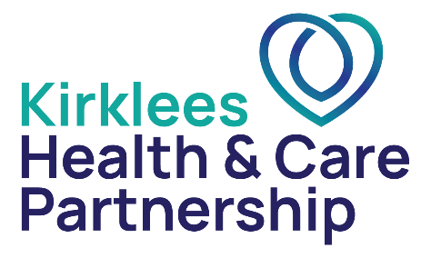



Please add GP surgery address and contact details here, with logo or photo in the next box.

Please send a copy of an easy read leaflet with this letter: www.gov.uk/government/publications/bowel-cancer-screening-easy-guide

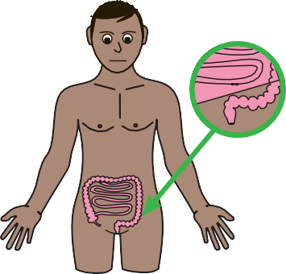
Dear

DOB: NHS No:

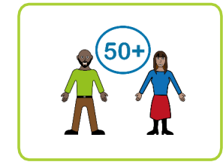
Everyone aged 50 and older gets a bowel cancer screening FIT kit in the post.

This is sent from the NHS bowel cancer screening programme because bowel cancer is more common in older people

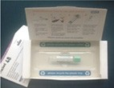
You test your poo at home using a FIT kit that looks like this.

Doing the test can help to find early signs of bowel problems that may need to be looked at.

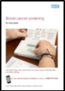
The leaflet that we have sent you tells you about bowel cancer screening.

It will help you make a choice.



You can choose if you want to do the test or not.



For further information about staying healthy in Kirklees please try these websites
- kirklees.gov.uk/beta/learning-disabilities/staying-healthy.aspx

- kirkleeshcp.co.uk/health-and-wellbeing/find-a-local-service/get-checked-out-kirklees/
Use your phone camera to click on the QR picture to see more information.
If you have any difficulty getting the information online and would like a copy of these documents printing out please contact:
Sarah Roberts Kirklees Involvement Network . Phone: 07710020235
Email: sarah.roberts@cloverleaf-advocacy.co.uk

If you are worried or have any questions then you can contact your GP and ask for more help.

