
Please do not send this document electronically. If you need to send a patient electronic versions for them to complete online please see the NHS Kirklees HCP webpage . Delete this text box before sending on.


Get Checked Out
Checklist

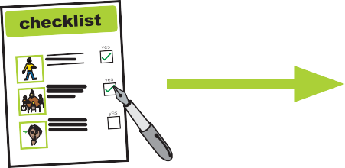
Please fill this book in and bring it to your GP surgery

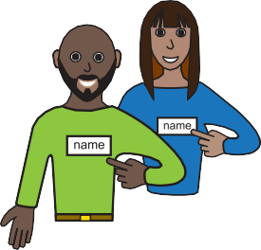
Name:

I like to be called:

My date of birth:

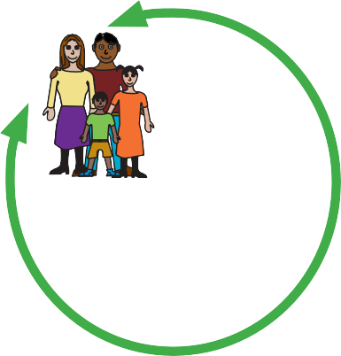


Who is important to you?


Address:

Telephone:
Email:



Your Doctor will have your basic summary care record.
It has information about your health, the medications which you take and any medications which might make you ill (allergic reaction)

A doctor or nurse who doesn’t know you very well, might ask to look at your Summary Care Record, this gives them the right information to care for you.
Consent for Summary Care Record and additional information


Only people like a doctor or nurse who are treating you can see your summary care record.
The Doctor can add extra information to your record with things like a history of your health problems, operations, or an illness you’ve had. It can include information about who supports you and what help or type of information you might need at appointments.
The extra information can help doctors and nurses, no matter where you are treated, look after you and help keep you well.

If you would like extra information adding to your summary care record about your health and what support you need let your Doctor know.

If you don’t want your information on your Summary Care record you can ask your doctor to remove it.

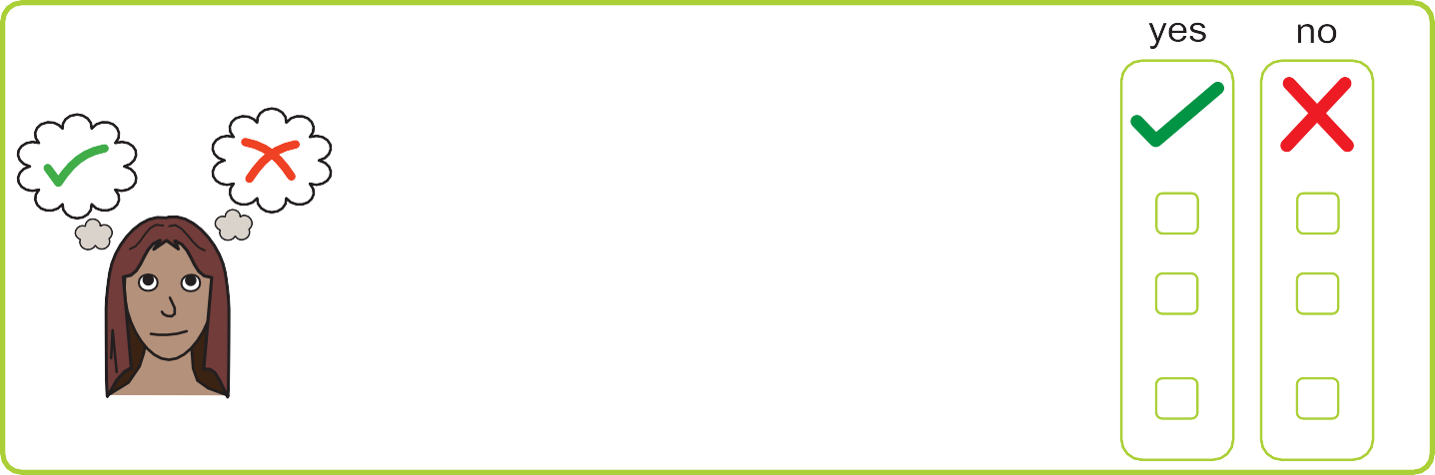

Do you consent to sharing information?

- Consent for electronic record sharing?
- Consent for summary care record with additional information?
- Consent to share data with another
professional? (specified third party)
2

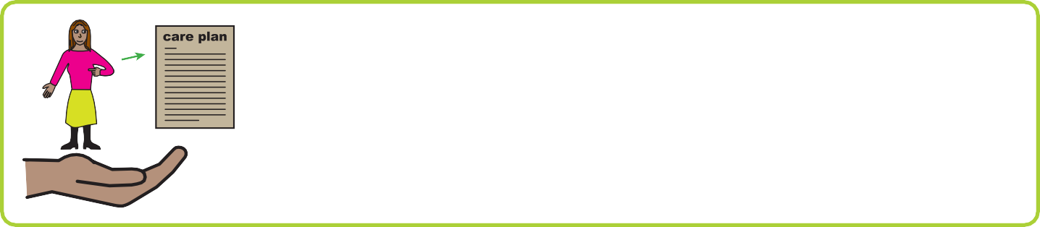
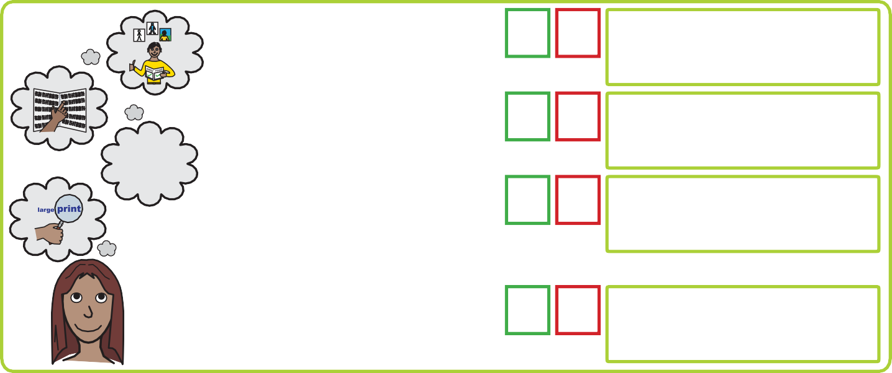




A reasonable adjustment is a small change your Doctor can make, to make your Annual Health Check easier for you.
Below are examples of reasonable adjustments or you can get help to write down what you need in the blank section.
You can ask for these reasonable adjustments to be available for you at your annual health check.
Reasonable Adjustment
How you can help me
Yes No
Comments

I need easy read documents.

I need information
in Braille or large print

I need access to on-line information.

I need information in another language – if so what language?
I use a wheelchair and will need a hoist if I need a physical examination.
I may need a home visit in this instance.
I find it difficult to wait in the doctors for my appointment, as it may make me anxious. I may need to wait outside until you are ready to see me.
I get very nervous at appointments and need my carer to help me understand what is happening.
3
The Equality Act (2010) Reasonable adjustments – Care Plan

Reasonable Adjustment
How you can help me
Yes No
Comments

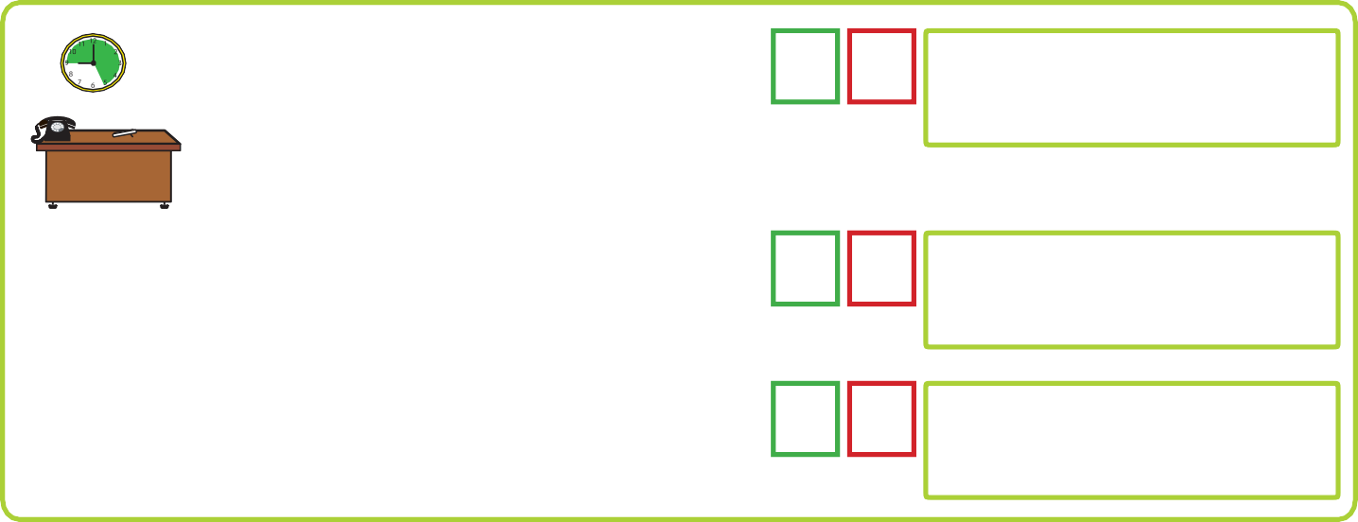
I may need to visit the surgery before my appointment to feel comfortable in the environment.
I need a longer appointment.
I need time to process information and answer questions.
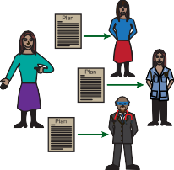
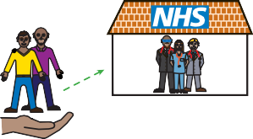
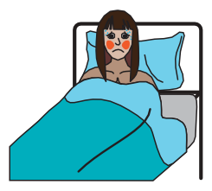
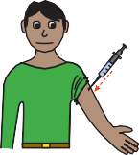
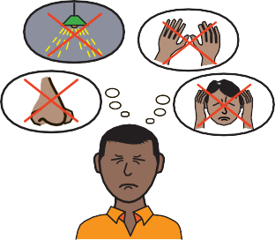
I may struggle with being touched or smells, hearing lots of noise, sight and how busy a building can be.
My carer will support you to understand my needs.

Please also alert my carer of any appointments.

Other reasonable adjustments?

Flu
Yes No


Comments

Have you had your nasal spray or flu vaccine injection?

For easy read information about flu go to the gov.uk website
www.gov.uk/government/publications/flu-leaflet-for-people-with-learning-disability

4

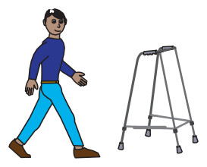

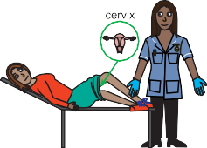

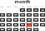
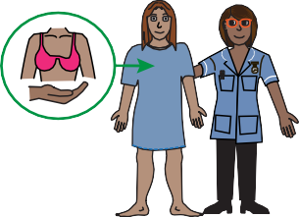

Mobility
Yes No

Comments

Stiffness or difficulty moving.

Slowing of movements. Pain when moving.
Falling or tripping.

Changes in posture/mobility. Mobility equipment used.
Swelling or redness in limbs/skin.

Health Screening - Women
Yes No

Comments

Have you had a smear test?

For easy read information on cervical screening go to the gov.uk website gov.uk/government/publications/cervical-screening-easy-read-guide

Change in periods e.g. heavy bleeding in between periods, painful periods,
Vaginal discharge
If there is a problem then please bring your menstrual chart with you if you have one.
If you are over 50 have you had a mammogram?
5

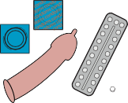

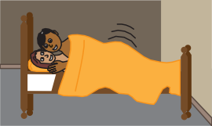
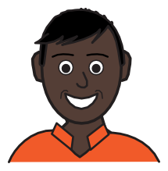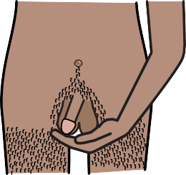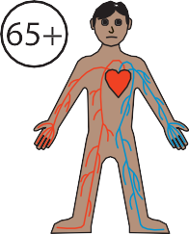
Yes No
Sexual Health
Comments
Are you sexually active?
Do you use any contraception?
Yes No
Health
Screening - Men
Comments
Have you had your Abdominal Aortic Aneurysm or AAA Screening?
For an easy read information about AAA go to the gov.uk website .gov.uk/government/publications/abdominal-aortic-aneurysm-screening-easy-guide

Do you check your own testicles / balls

Have you felt/noticed any changes to your testicles/balls?
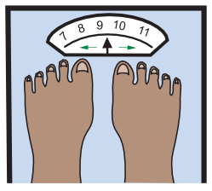
Yes No
Weight
Comments
Has your weight changed in the last 3 – 6
months?
Do you need specialist equipment to weigh you?
If there is a problem with your weight then please bring your weight chart
6

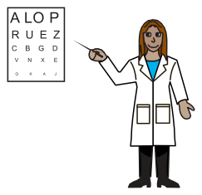



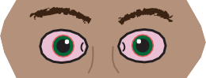
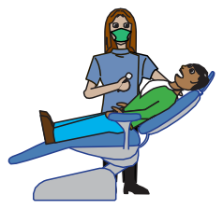
Yes No
Eyes
Comments
When did you last have your eyes tested
Do you have any eyesight problems or wear glasses
Yes No
Dentist
Comments
Do you have a dentist? When was your last visit?

Do your teeth hurt? Do your gums bleed?
Do you have a swelling or a lump?

Do you have difficulty eating?

Yes No
Hearing
Comments
Have you noticed any problems or changes to your hearing?
Have you visited a hearing clinic (audiologist)?
7


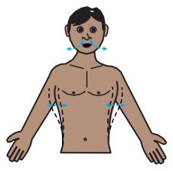
Yes No
Eating and
Drinking
Comments
Does eating make you feel unwell?
Food allergies/intolerances
Being sick

Do you have any changes to your appetite/hunger?
Do you eat things that are not food?
Difficulty swallowing
Coughing when eating or drinking

Do you use any supplements like multi
vitamins, fish oils, Complan etc.?
8
Yes No
Breathing
Comments
Coughing that won’t go away (more than 3 weeks)

Chest infection

Coughing up blood
Unusual coloured spit Wheeze
Hay fever, allergies, asthma or
chronic obstructive pulmonary disease Breathlessness
Do you smoke?

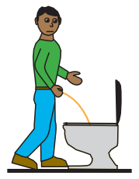
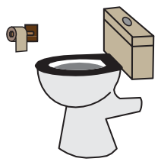
Yes No
Urine
Comments
Pain when you wee?
Urine infection
Wee more often?
Do you find it difficult to start weeing?
Does your wee start and stop when you are weeing?
Blood in your wee
Difficulty in getting to the toilet in time?
9
Yes No
Bowels
Comments
Constipation – hard poo or can’t go to the toilet
Diarrhoea– watery poo and going too much

Bleeding from your bottom
Difficulty getting to the toilet on time
Changes in bowel pattern Fatigue

Are you aged 50 or older? Have you received
your bowel screening kit?

For easy read information on bowel cancer screening go to the gov.uk website gov.uk/government/publications/bowel-cancer-screening-easy-guide

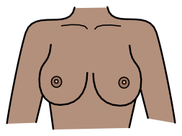
Yes No
Breasts
Comments
Any lumps in breasts or armpits?
Any liquid from your nipple?

Any changes in the shape of your breasts?
Any changes to the skin on your breasts?
Any changes to shape of your nipples?

Do you have a change in colour to your breasts or nipples?
Do you get tired more easily?
For easy read information on bowel screening go to the gov.uk website
gov.uk/government/publications/bowel-cancer-screening-easy-guide

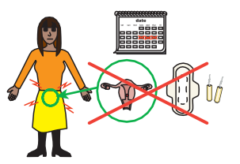
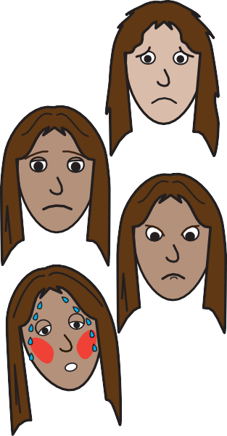
Yes No
Menopausal
symptoms
Comments
Do you feel tired?
Do you have mood swings?
Do you feel sad?
Do you feel irritable?
Do you have hot
flushes?
10

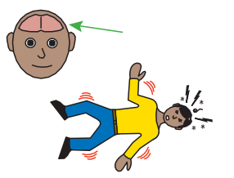
11

Brain
Yes No

Comments

Do you have epilepsy?

How many seizures per month? Any changes to seizure?
Under the care of an epilepsy
specialist(neurologist)

When did you last see them?

Triggers for Epilepsy e.g. lights, TV, tired , temperature, infections
Do you take your epilepsy medication regularly and as prescribed?

Do you have any side effects i.e. dizzy,
sick, vision, irritable?

Have you had any of the following:

Stroke Fainting Blackouts
Pins and needles

Arm or leg weakness
Please bring your seizure chart with you, if you have one.
11

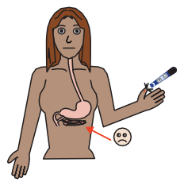
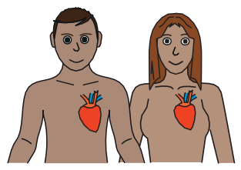
Yes No
Diabetes
Comments
Do you test your blood sugar regularly?
Please bring your blood sugar charts if you have them
Do you have any problems with your eye sight?
Have you been for your diabetic eye screening?
When you have eye screening, we put drops in your eyes and take photographs of them.
For easy read information on diabetic eye screening go to the gov.uk website gov.uk/government/publications/diabetic-eye-screening-easy-read- guide
Yes No
Heart
Comments
Difficult or struggling to breathe during the
day and at night
Chest pain when exercising
Palpitations – feeling your heart beat
Any swelling to the ankles, hands or body?

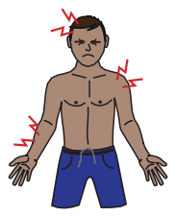
Yes No
Pain
Comments
Do you have any pain?
Does your pain relief medicine help to stop or reduce the pain?
12

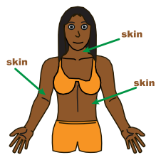
Yes No
Skin
Comments
Dry or Itchy Skin
Prescribed Skin Cream Warts
Cold Sores
Sores or open wounds

Pressure area concerns
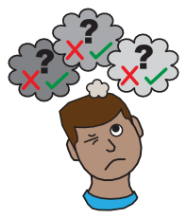
Yes No
Mental Health
Comments
Any Worries about your Memory or confusion
Are you low, sad or unhappy?

Are you worried, frightened or anxious?
Do you feel like crying?

Have you injured yourself since your last review?
Do you feel like you can’t cope or look after yourself?
Do you feel irritable, aggressive or violent?

Have you thought about harming yourself or actually harmed yourself?
Do you hear voices or see things?
Have you spoken to someone to about how you feel?
13

Medication Review
Yes No
Feet
Comments
Have you been to a podiatrist
(foot specialist)? When did you last go?

If no, who cuts your nails?
Do you have any pain in your feet?


Your Doctor will talk to you about your medication and look at whether your medication is right for you.
People with a learning disability are sometimes given medication they don’t need; your doctor will talk to you if he needs to change yours.
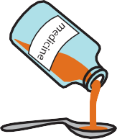

How do you take your medication? Can you swallow a tablet?
Do you need liquid medication?
…………………………………………………………………………
…………………………………………………………………… Please bring a list of your medication with you


Yes No
VIP hospital
document
Comments
Do you have a VIP hospital document?
This helps hospital staff understand how
to help you
14

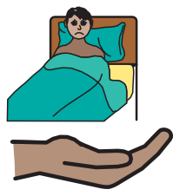
Palliative Care
Comments
Are you receiving support from palliative care services like a hospice or Marie Curie Nurse?
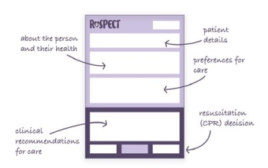

End of Life Gold Standard Framework

Comments

Do you have a ‘DNAR’ (Do Not Attempt Resuscitation) or ‘ReSPECT’ Document. Any concerns or questions about these documents?
Bring a helper

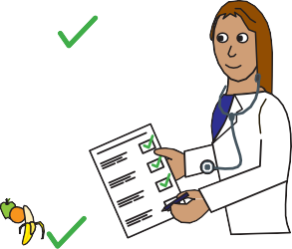
You can ask questions at your health check.

You can bring someone with you who can help you in the appointment. You can decide if they will stay with you for some or all of the appointment.

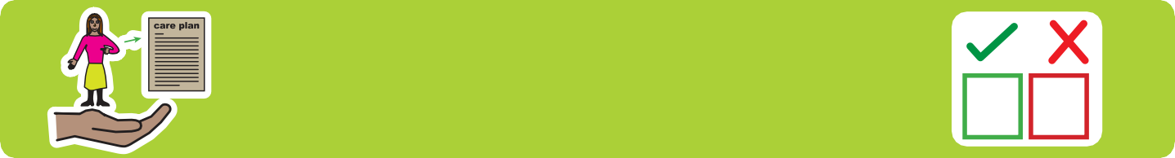

Do you have an advanced care plan?
Here is a link for further information on end of life and advanced care planning
www.kirkleeshcp.co.uk/health-and-wellbeing/find-a-local-service/get-checked-out- kirklees/end-of-life-care-and-advanced-care-planning-information-and-resources/

Do you have any questions?


I
15

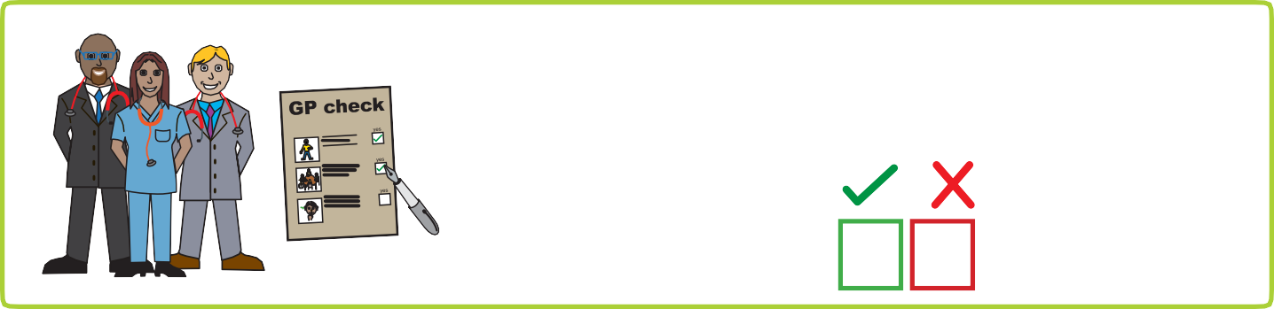
At the end of your Annual Health Check, you should receive a copy of your Health Action Plan.
Yes No

Did you receive yours?

Thank you for completing this form.

Please bring it with you to the health check appointment along with any other important documents.


Use your phone camera to click on the QR picture to see more information.
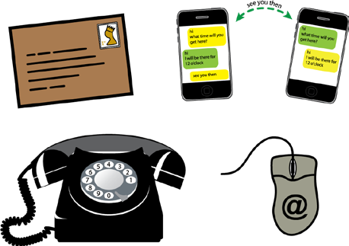

Or visit www.kirkleeshcp.co.uk/health-and-wellbeing/find-a-local-service/get-checked-out-kirklees/

For further information about staying healthy in Kirklees please visit the Kirklees council website:
kirklees.gov.uk/beta/learning-disabilities/staying-healthy.aspx

For more information on any of the health conditions please visit the easy health website www.easyhealth.org.uk

If you have any difficulty getting the information online and would like a copy of this document printing out, please contact:
Sarah Roberts Kirklees Involvement Network
Phone: 07710020235
Email: sarah.roberts@cloverleaf-advocacy.co.uk

