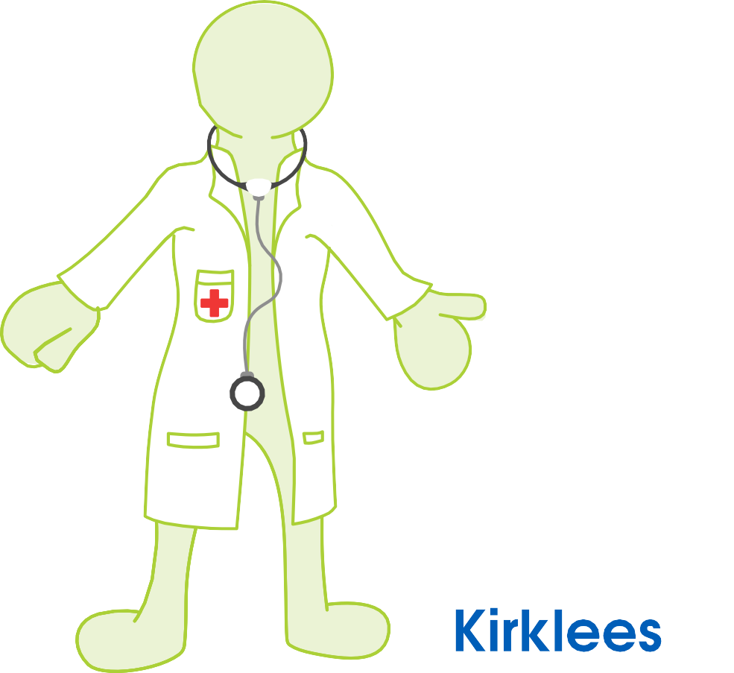
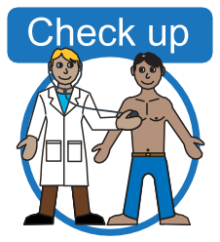
free health check 
for
over 14's

- Do you have a Learning disability?
- Are you over 14?
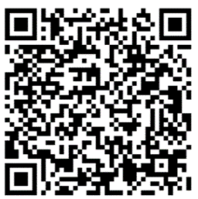
Ask for a free learning disability health check at your local GP practice.

Use your phone camera to click on the QR picture to see more information.
Or visit www.kirkleeshcp.co.uk/health-and-wellbeing/find-a-local-service/get-checked-out-kirklees/

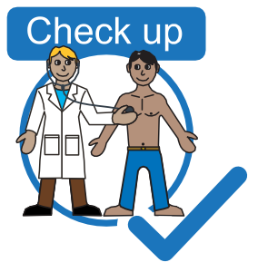
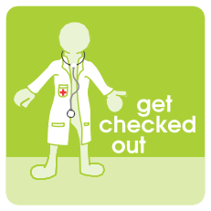
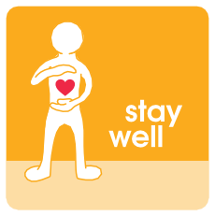
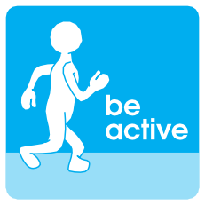
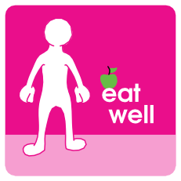
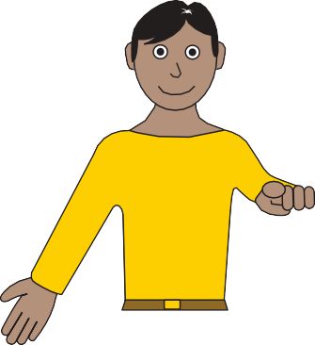
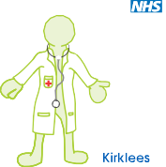
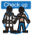

What can you do

- Visit your GP for a free health check for people with learning disability.

free health check
for
over 14's
- Do you have a Learning disability?
- Are you over 14?
Ask for a free learning disability health check at your local GP practice.
- When you visit your GP take this flyer to help you ask.

