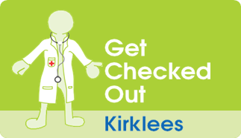
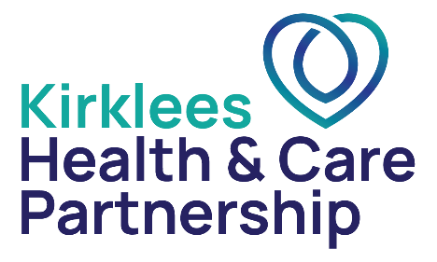

Annual Health Check
Information for families and carers

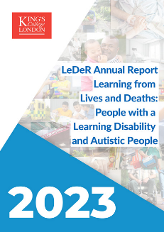

The Learning Disability mortality review programme (LeDeR) is an ongoing study that looks into the causes of death of individuals with learning disabilities.
The Annual Report says that people with learning disabilities die at a younger age compared to those who do not have a learning disability.
Many of these deaths are because people with learning disabilities often have poor access to health services

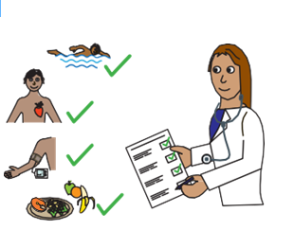
Annual health checks are completed at your doctor’s surgery and are a way to make sure that health problems are found and can be helped quickly.
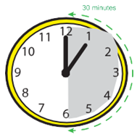
Annual Health checks are being offered to people with learning disabilities over the age of 14. They are a way to support good health and wellbeing and help to lower health inequalities.
The annual health check is a top to toe review of health and should include a check-up of your body in person.
It should last for a minimum of 30 minutes in total. It may be that you see more than one professional to complete the check.

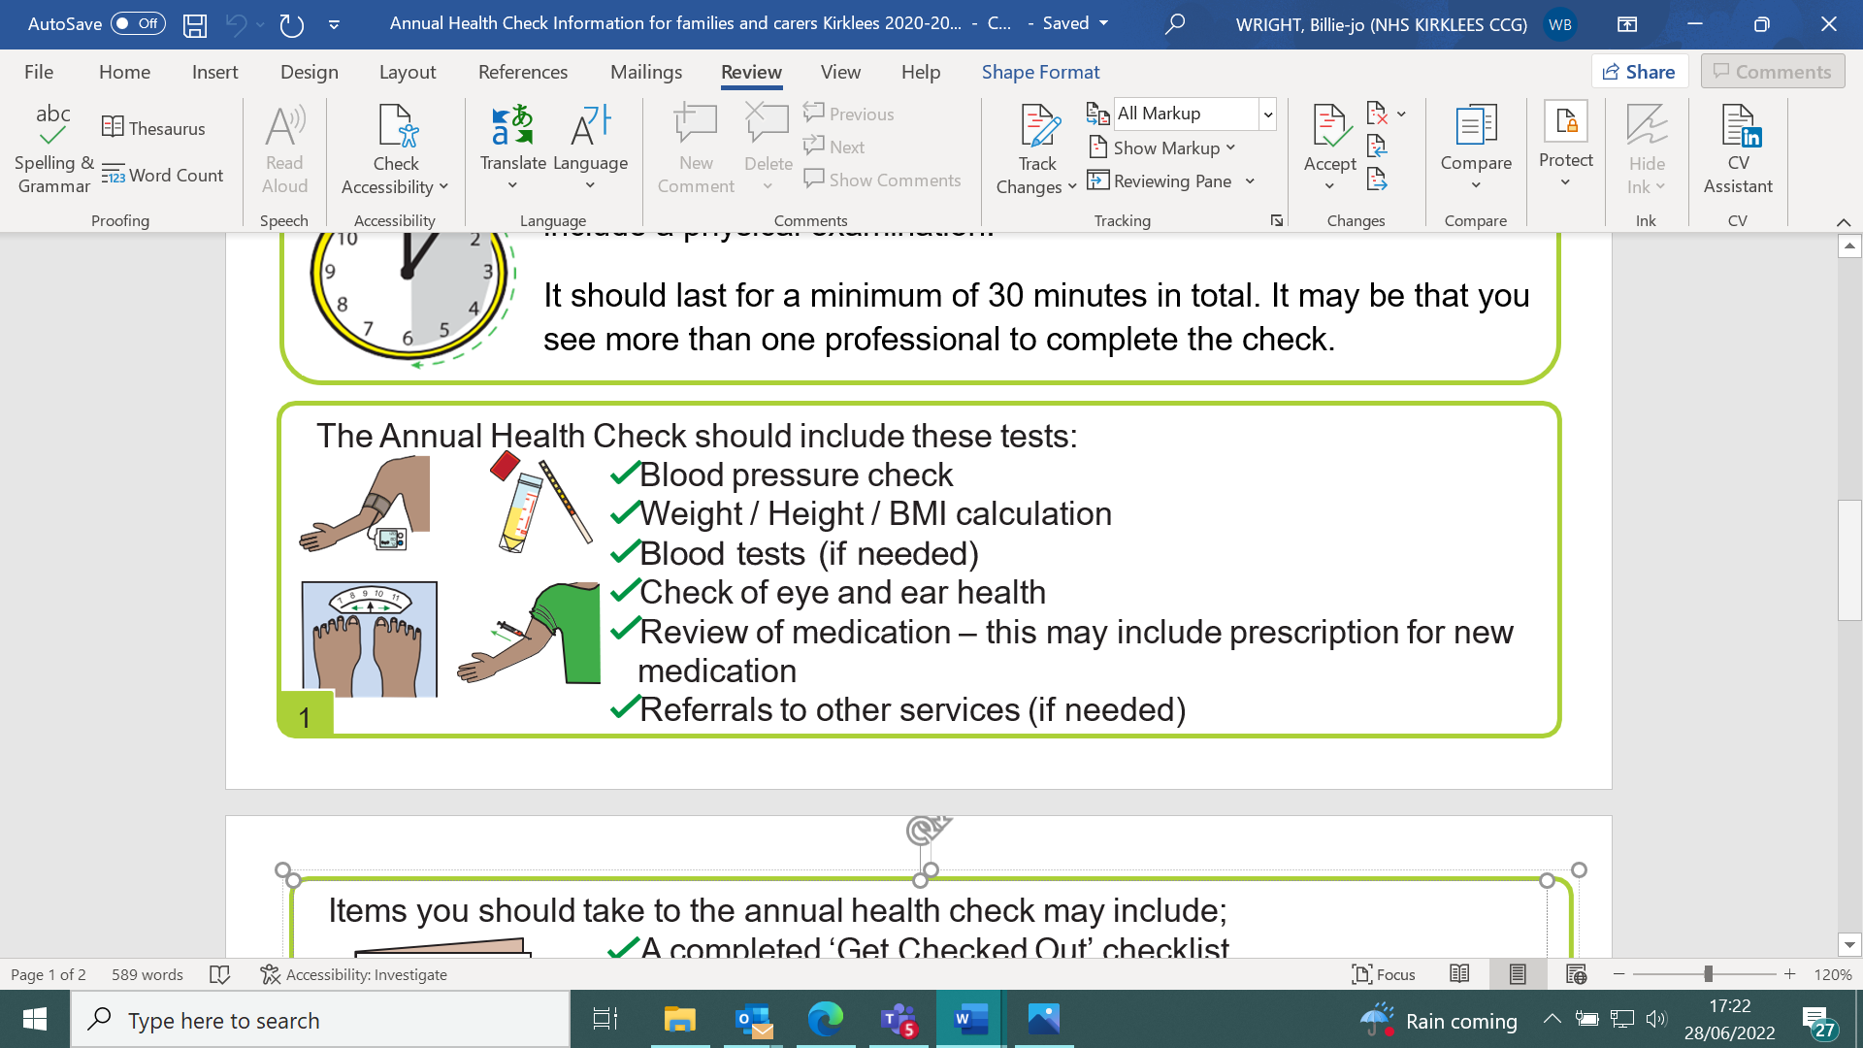

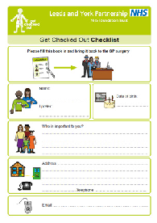
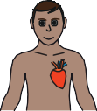
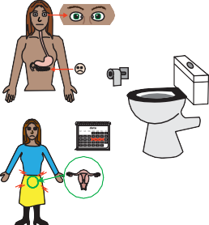


Items you should take to the annual health check may include;
- A completed ‘Get Checked Out’ checklist. You should spend time completing the ‘get Checked Out’ document with the patient
- A urine sample
- Monitoring charts for bowel care, epilepsy etc.
- Medication sheets
- Take up to date contact details of important people like family/carers and inform reception staff of any changes.

During the appointment the Doctor may ask the person if they have been invited for appropriate screening tests. Another word for screening is a test or a check-up.
These might include:
- Diabetic eye retinopathy – for everyone with Diabetes
- Breast screening – For women aged 50 – 70 years old
- Cervical screening (sometimes called a smear) – For women and people with a cervix aged 25 – 64
- AAA screening for men - For men aged 65 and over, this is for your heart.
- Bowel screening for everyone aged 50-74

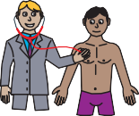
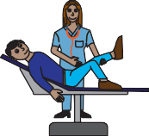
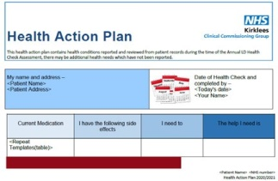
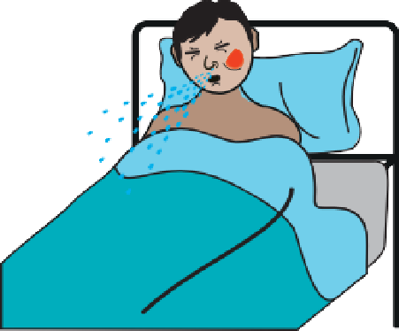
After the check, the Doctor will give you a copy of the Health Action Plan, this tells you what happened in the appointment and what should happen next.
A Health Action Plan might include the results of the health check. It will tell you what need to do next to support the patient. For example: an appointment at another service.
If there are no follow up tests or appointments to be made after the Annual Health Check, then the patient will be invited back next year for their next Annual Health Check.

If it is appropriate, an immunisation like shingles or flu may be offered. This is also know as an injection or jab.
If the patient is worried about needles, talk to the Doctor about the nasal spray instead. More information can be found on the website: www.kirkleeshcp.co.uk/health-and-wellbeing/find-a-local-service/get-checked-out-kirklees/national-health-screenings-and-vaccinations/

For further information about go to www.kirkleeshcp.co.uk/health-and-wellbeing/find-a-local-service/get-checked-out-kirklees/ or www.kirklees.gov.uk/beta/learning-disabilities/staying-healthy
For more information on any of the health conditions please visit the easy health website: www.easyhealth.org.uk
If you would like a copy of this document printing out please contact: Sarah Roberts, Kirklees Involvement Network, Phone: 07710020235 Email: sarah.roberts@cloverleaf-advocacy.co.uk
2

